TA STATION PROBLEM ANALYSIS PROCEDURE

20090611 rev 1.4 aws

A weekly report is generated on Thursday mornings. This procedure outlines how to fill out the station problem and servicing analysis portion of that document.

Download last week’s Word report sent out by Bob Busby subject labeled: Re: TA Weekly Summary: January 22, 2009 (APPROVE) and rename it with the present Thursday’s date. Edit all date lines in it to reflect the correct dates (mostly add 7 to each date, except for holidays).

Fill in the following sections of the report, erasing outdated information:

Known Station Issues

Reboot Issues

Low Power Stations

High Power Stations

IRIS DMC Waveform Review Weekly Report

Pump Active

Service

Service Scheduled for next week

Also – the first week of the month the following additional section will be submitted:

9. Engineering Development

Most of this document will cover filling out section 1., but the other sections are addressed as well.
There are several places to examine the real time operation of the TA stations. This writeup will go through the process used to put together the “Station Problems” section of the TA weekly report. The principal web pages used to produce it are:
- http://www.iris.edu/servlet/quackquery/multiplot_networks.do - the DMC page that shows the daily percent availability of data for each station. Stations that show less than 100% data availability will be flagged for further examination.
- http://anf.ucsd.edu/tools/dlmon/webdlmon.php - This ANF page shows the general health of each station in a tabular form.
- http://anf.ucsd.edu/tools/soh/plots.php - This ANF page shows the individual station State of Health (RRD) plots
- https://portal2.backoffice.wildblue.net/portal/dt (from IE browser only) – This Wild Blue site shows the WB state of health for TA VSAT stations
- various other ANF pages and automatic emails generated by ANF are also used
- in addition, DMC produces a weekly report on the sensor problems they see in the data
Tools used to further examine the state of health of the stations are:
- Willard – allows individual TA Q330s to be queried
- AceManager – allows the Airlink Cell modem signal strength to be checked

Depending on how much time is available and how many stations are having troubles, the following procedure may be abbreviated – the overall goal of this procedure is to identify problem stations and give probable-cause information to assist servicing.

Using Quack to Identify Stations with Poor Real-Time Data Thruput for the Previous Month:

- Go to http://tinyurl.com/aktyeq
- Click on the Filter Icon on the left to see:
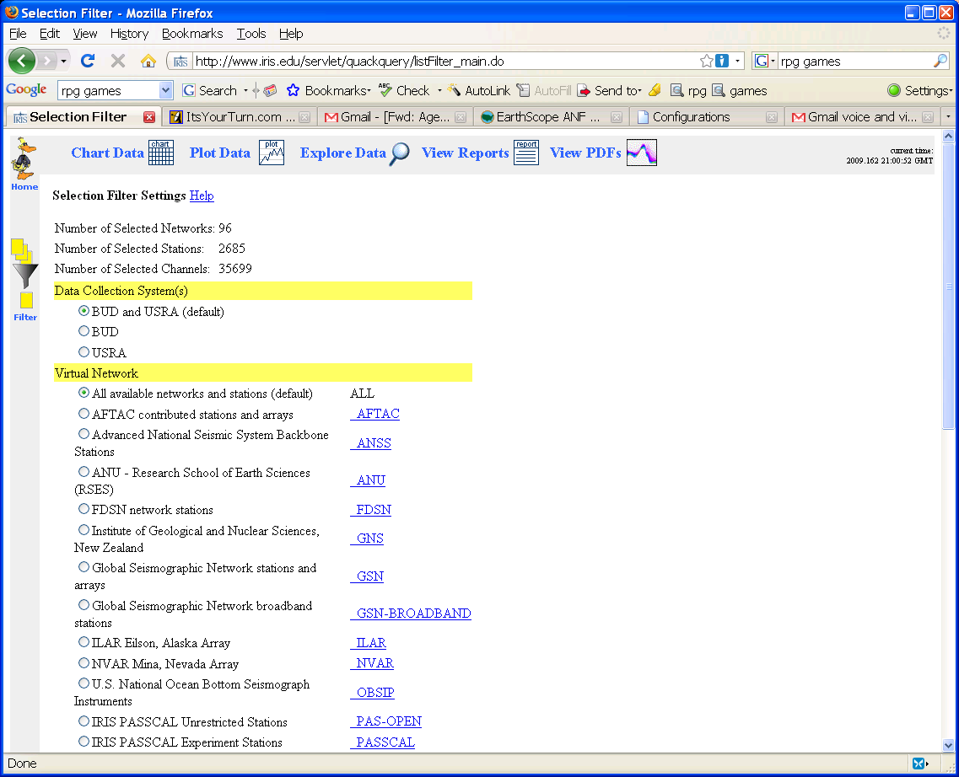
Scroll down and choose: Channels active during the last month.
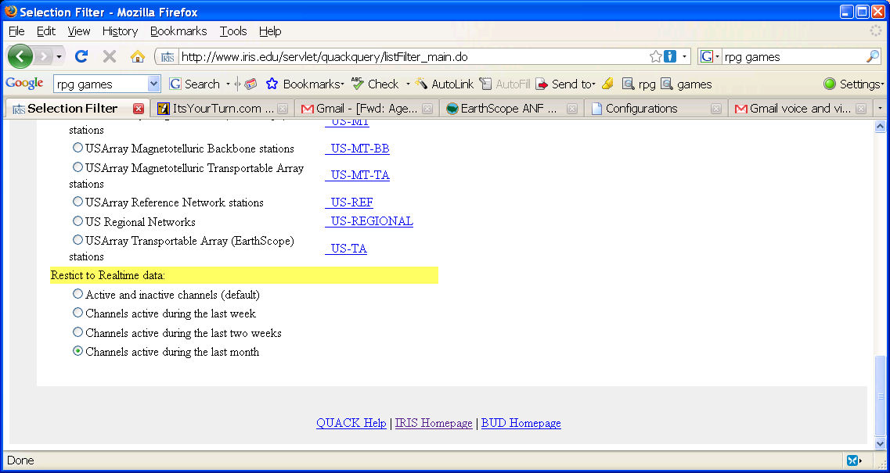
- Scroll back to the top and click on the Plot Data option:
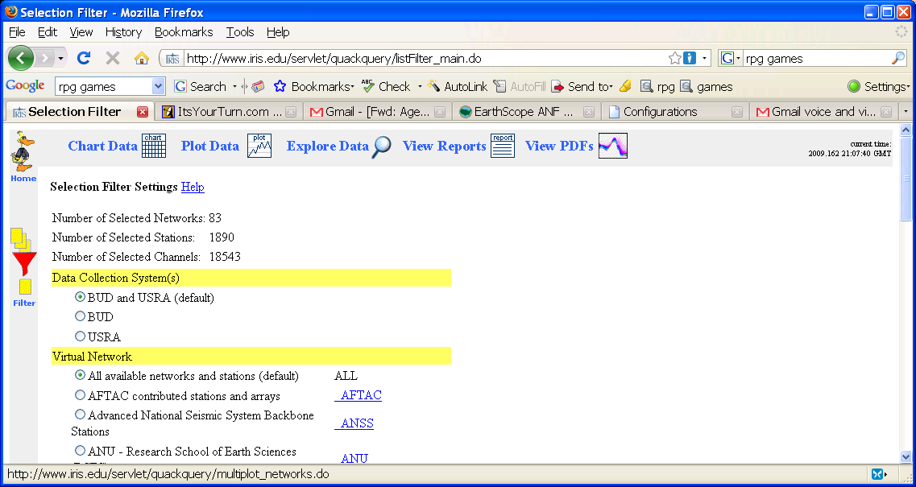4) Scroll down and click on TA in the right column:
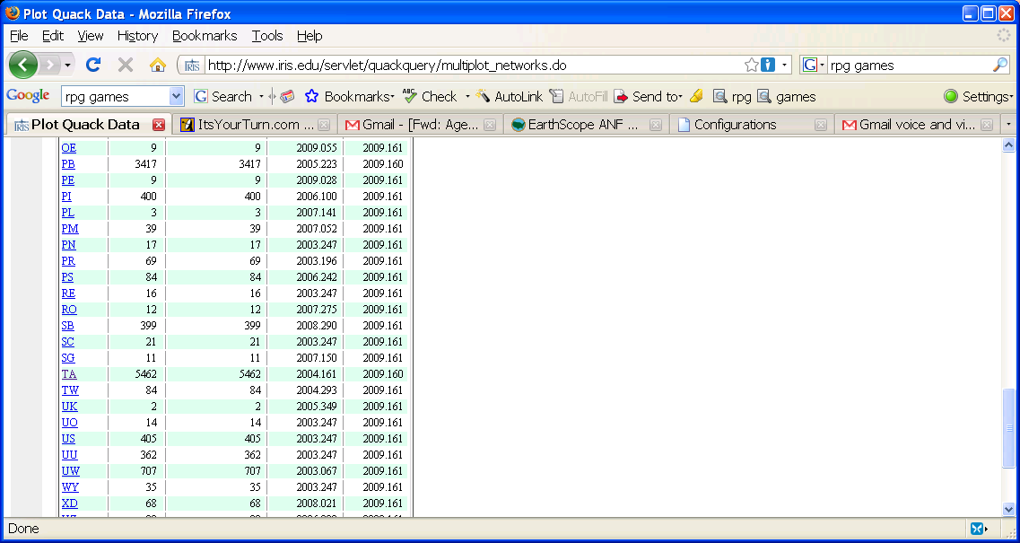
5) Choose “LHZ” from Available Channels and “Select All” from Available Stations.
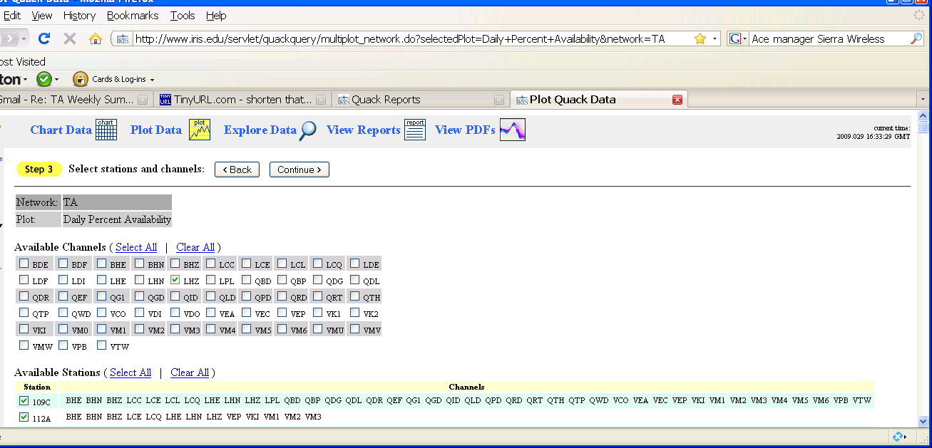

6) Click Continue
The following page will appear:
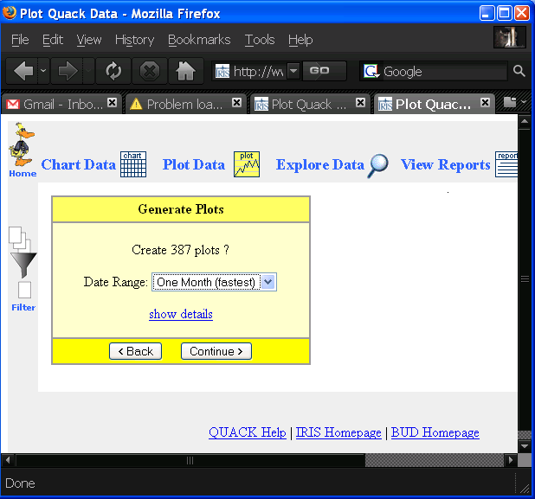

7) Choose the Data Range to be One Month, then click Continue. DMC will begin producing plots and all 387 (in this case) will be shown in one long browser window. The following plot shows a screen capture from 2 stations of the DMC plots. Each shows a notch below 100% right after Oct 30th. It turns out that virtually all 387 plots have the same notch after Oct 30th. We assume this dropout is caused by an ANF problem and is not an individual station problem. So A04A is the first station that shows a significant dropout in the past month. Instead of showing all the plots, just the first few stations are shown, then a list of the stations showing individual data dropouts for the past month are compiled after the plots.

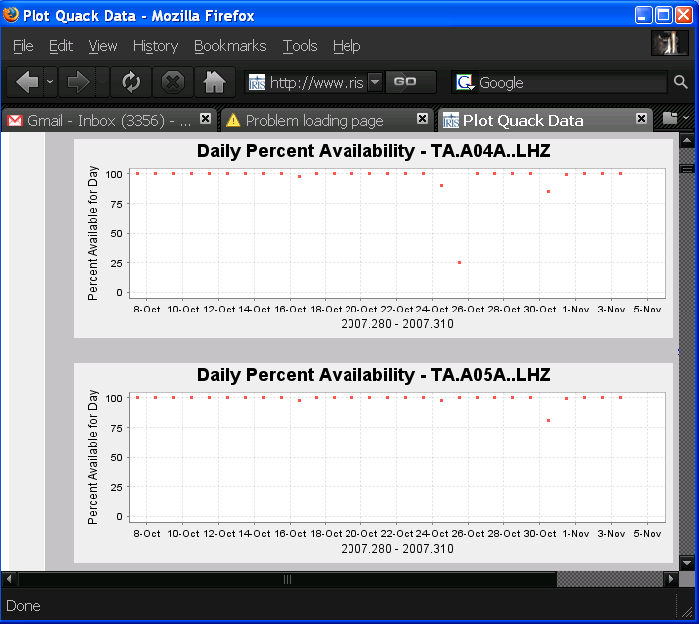

Not A05A – it is the standard
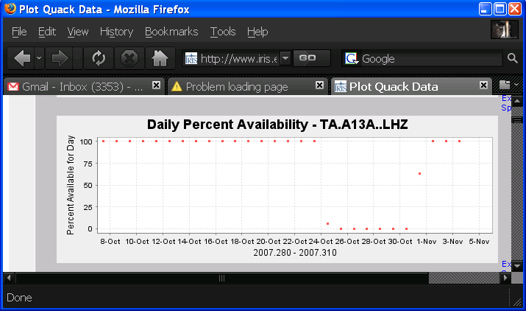

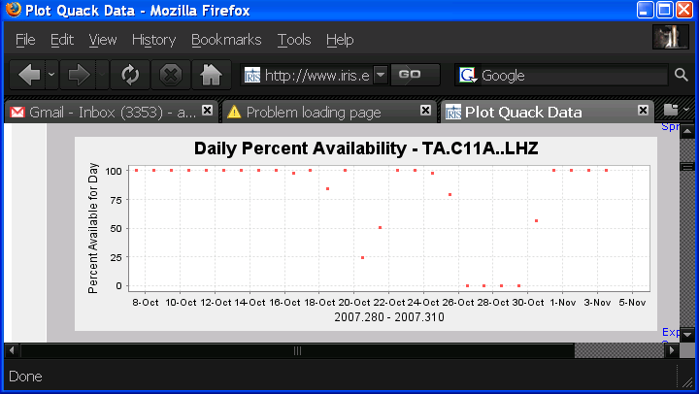

8) The Quack problem list is sorted by present versus past problems:
Past problems - presently delivering all data: A04A, A13A, C11A, D10A, E15A, F12A, G05A, K01A, N10A, R15A, U04C
Present problems - C14A, E03A, G12A, H13A, I04A, J03A, J04A, J05A, K06A, M07A, M13A, O09A, P12A, P15A, R16A, U13A, V12A

Using ANF DLMON to Identify Stations that are Presently Experiencing Problems

9) Another tool we use is the ANF dlmon tool:
http://anf.ucsd.edu/tools/dlmon/webdlmon.php
Stations with data gaps migrate to the top of the list. We will see how many of the presently gappy stations also show up in the Quack pages (note there is a 2 or 3 day delay in the Quack plots)
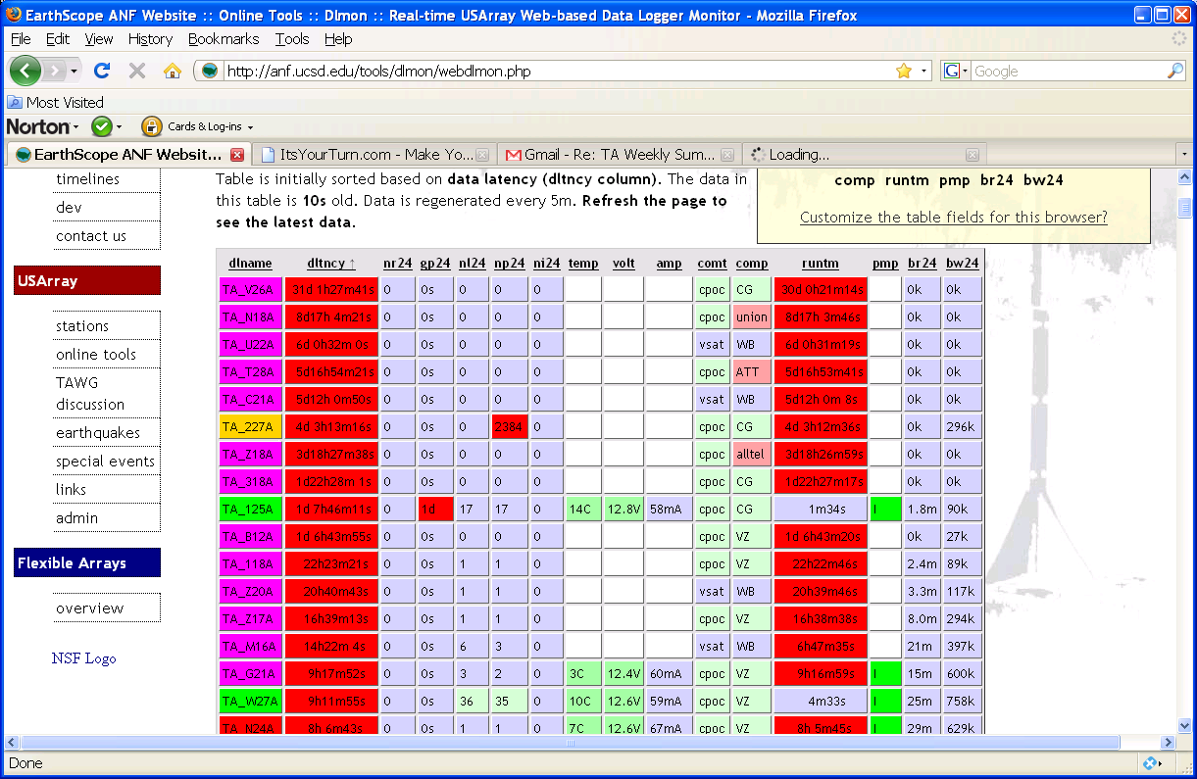

A blowup of the upper left section follows for legibility. The first column shows the station name. Green indicates good thruput, yellow, red or violet indicates 1) Null datalogger ip, 2)Sleeping after connection setup failure, and 3)Hibernating respectively – all non-realtime data flow states. The second and third columns indicate the communications type: vsat Wild Blue satellite modem; cpoc Verizon or Cingular cellular modem; rint and cble direct Ethernet connections. The 4th column shows gaps in the past 24 hours. The column headed nr24 shows the number of reboots in the past 24 hours. Then pump information – green I if pump is present, ON if pump is on. Dtlncy is the age of the packet last received – if the bar is red, it measures how long since data has been received. Other columns we look at are: nl24 (number of comm link cycles in the past 24 hours), np24 (number of POC messages received by the Q330 in the past 24 hours), volt (digitizer voltage), and gps (clock quality)

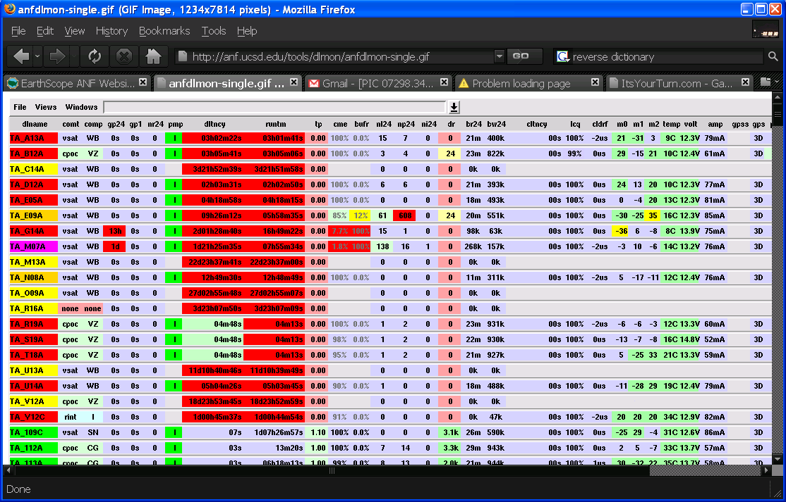

10) Now we’ll make a list of communication problem stations from the ANF DLMON page (offline more than a day), and the Quack list subtracting off those which were recently removed or serviced:
These are stations presently down over a day: A13A, C14A, G12A(in and out of service), G14A, H13A, M07A, M13A, O09A, R16A, U13A, V12A

These stations are working now, but we can check the past month’s RRD plots to see if they appear to be barely working or not: A04A, C11A, D10A, E15A, F12A, G05A, K01A, N10A, U04A

- We start with the presently down stations. If a station has a Cell modem, the first thing to check is can we connect with Ace Manager to the cell modem.
- To find Start Willard and choose “Manager”
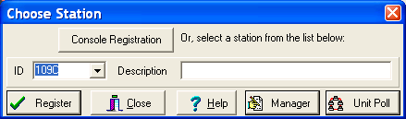
- Choose “Config Server”
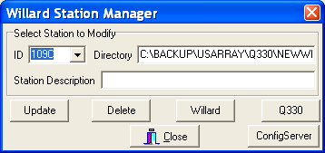

14) Click on “Show Station List” unless some other config server is chosen other than http://anfpublic.ucsd.edu:8133 (http://ta-config.isti.com:8311 also works). If either of these aren’t entered, click on the upper right-hand “Choose” button and enter the anfpublic server. You do not need to enter in a username or password.
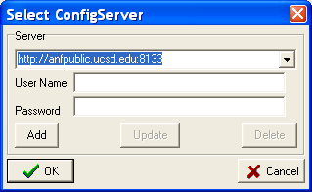

- Click “OK” and then click on “Show Station List” at the page bottom. You will see the following page:
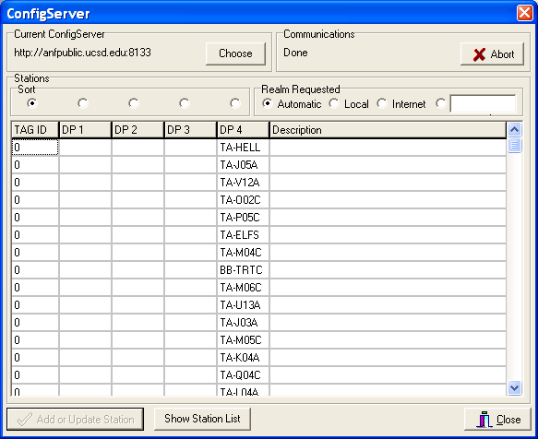

- Click on the radio button below “Choose” and above “DP 4” – this will order the stations alphabetically. Next click on the first station to examine (A13A) in the DP 4 column. The following page will appear. Click on Ethernet and then click on “Add or Update Station”
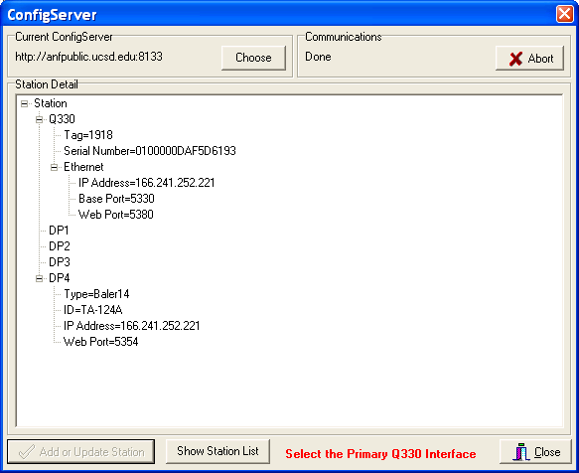

- Right below the Ethernet entry is the IP address of the station. We will try to connect to that IP with Ace manager.
- Download Ace Manager, if it isn’t on your computer, by going to: http://www.sierrawireless.com/support/default.aspx
- Select Verizon carrier, select product Raven X-EVDO, platform English, Windows, click “Next”
- Put cursor on Ace Manager and Click. It will download a 11M file. Once it is downloaded, double click on the install file. Once the AceManager icon shows up, you can run AceManager by double clicking on it to see the following window:
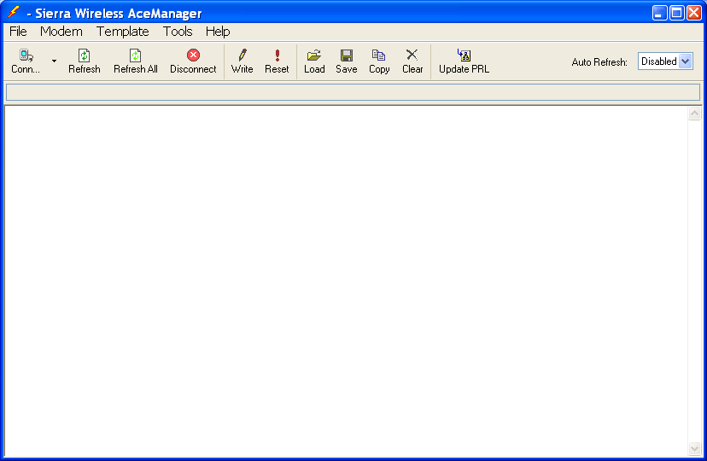

- To connect to a known radio’s IP, first click on the “Conn” button above to get:
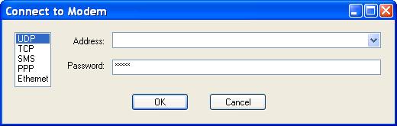
- Make sure UDP or TCP is chosen and enter the IP address in the address line. The most common password to use is: 53805380, but the older password: 5380 is occasionally encountered, and new radios’ default password is: 12345
- Click OK. After a while the following screen will show up for a radio that isn’t able to be connected to on the internet:
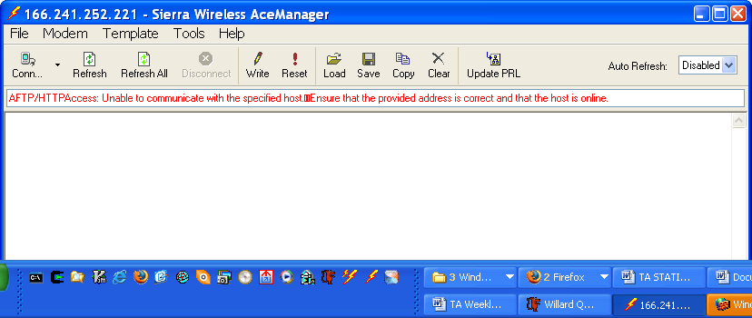

24) If this is the case, jump to section below titled: “Checking RRD Plots for Stations with COMM Dropouts in the Previous Month” and look at the ANF plots for the State of Health for the vault power and RSSI.

- If you try to connect to a radio that is online, but you use the incorrect password, you get the following error message indicating an incorrect password:
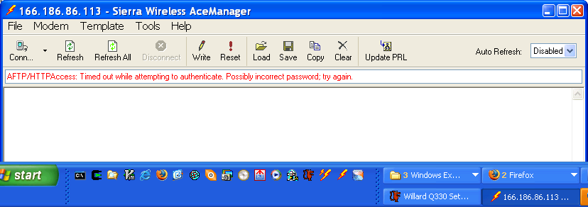

- For a connectable station using the correct password, you will get the following window:
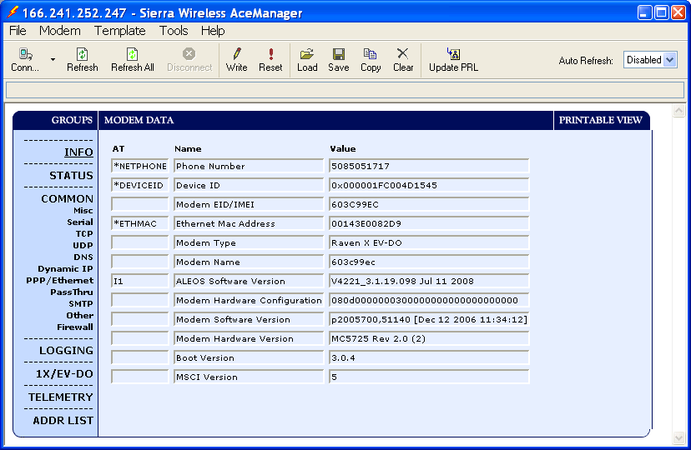

- Click on the Status tab to see how the modem is doing:
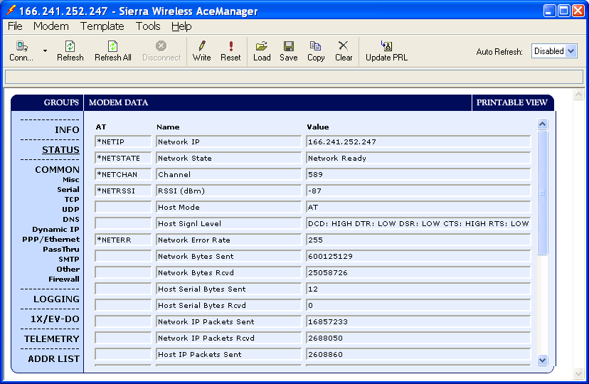
- Network is ready, RSSI is -87 ( smaller than absolute value of -90 is great).

- If the station’s modem is reachable, try reaching the station with Willard.

- If you haven’t accessed this station with the willard you are using on the PC you are using, you will see the following screen. Click “Create”.
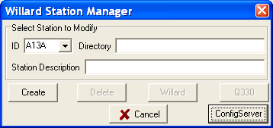

If you’ve already accessed this station, the above window will be skipped and the next window will appear.

- The Q330 serial number and IP will be pulled from the config server. Click “OK” in the next box:
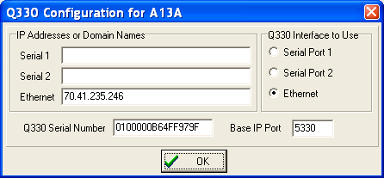

- Again, if it’s a new station being accessed, the following info box will appear. Otherwise, this window will be skipped. If it appears, click “OK” again:
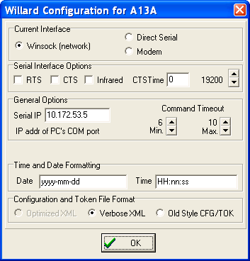

- Go back to the Config Server box and click on “Show Station List” to configure the next station in the list:
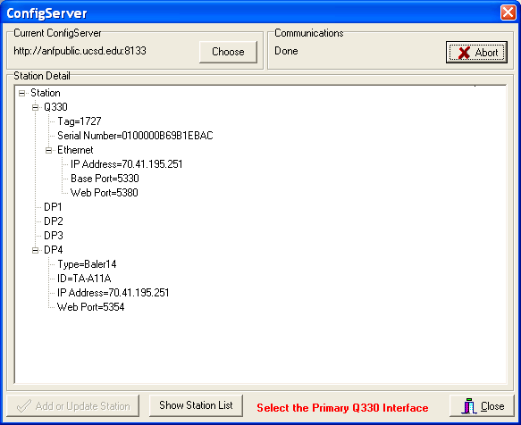

- This will take you back to the Config Server station list. Click on the next station in the list of ones to examine for present connectivity
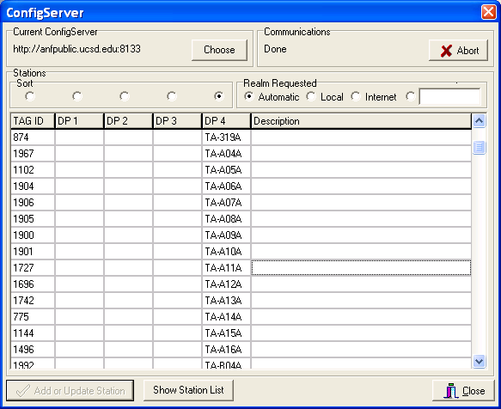

- continue going through steps 26) through 30) until all the stations in the list are configured. Next, we connect to these stations using willard and see if any are reachable. None are. Now we will start a text file with the information we have gathered so far. It will be cut and pasted into the TA Weekly summary. Open a new text file and enter the stations w/ present problems that have been out of communications with ANF for over a day and list how many days they’ve been out:
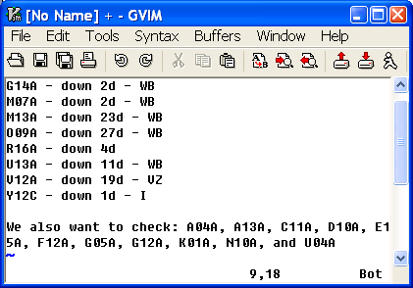

- As is usually the case, the most outages are WB stations. We now go to the WB SVT page for each site to see what their status is. It is helpful to download and open the latest WB_info200???????.xls file from TAops disk :\Instrumentation\Procedures & software\WildBlue. This contains the station WB MAC addresses so one can connect to the various stations. Open this file:
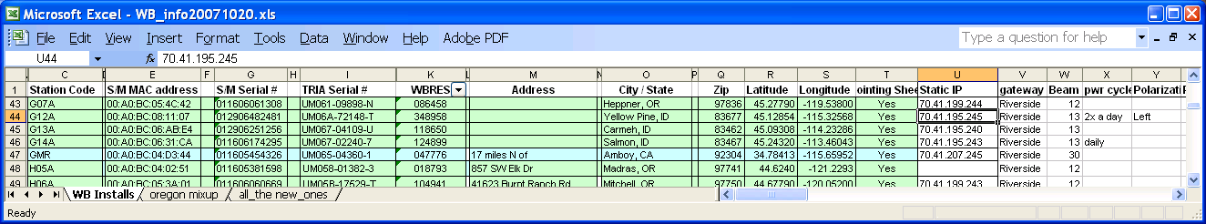

The pertinent columns are the Station Code, S/M Mac Address, and the Static IP. Scroll down to the first station on the WB outage list (G14A) and note whether it has been assigned a Static IP.

- Open a Internet Explorer browser window and go to:
https://portal2.backoffice.wildblue.net/portal/dt:
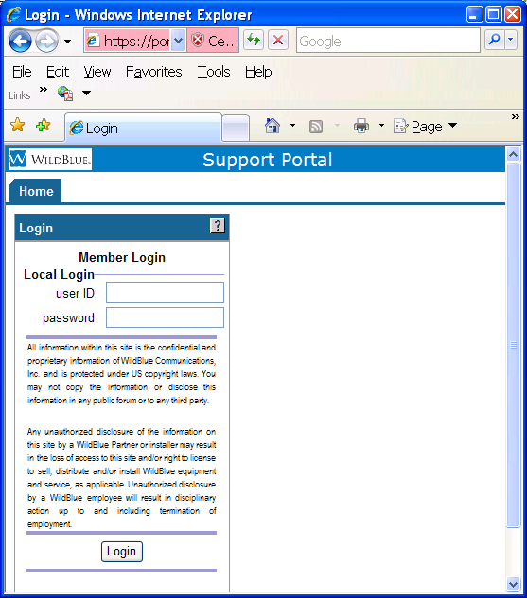
The first station has a static IP assigned and we will log in to the WB web page as CRG03 (irista). If a static IP has not been assigned, log in as 14380 (hello1).

- In the page below that opens up, for Static IP’s usually typing the station code as the first name, and Busby as the last name will connect. If not, copy and paste the S/M MAC address from the excel spreadsheet into the MAC address
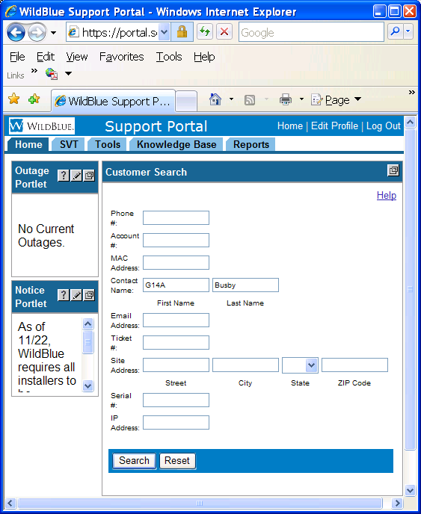

Click on “Search”.

- If the station is found in the WB data base, some information about it will appear in the right column.
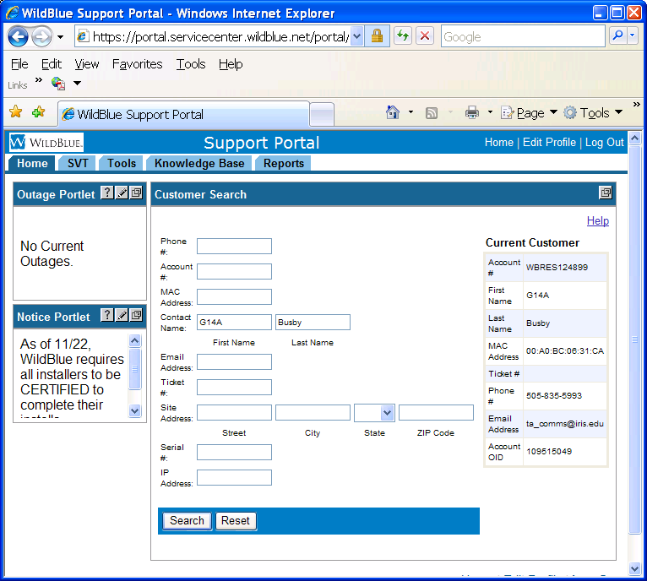

Click on the “SVT’ tab to see information about current connectivity between the Satellite Modem and the Wild Blue center – give it some time to collect it’s thoughts. We see below that the two left-most columns are without information – labeled “Table Incomplete” This indicates that the link between the Satellite Modem at the TA station and the Satellite (and WB central) is broken. Click on the lower left “Historical Plots” to see a time series of the connectivity.
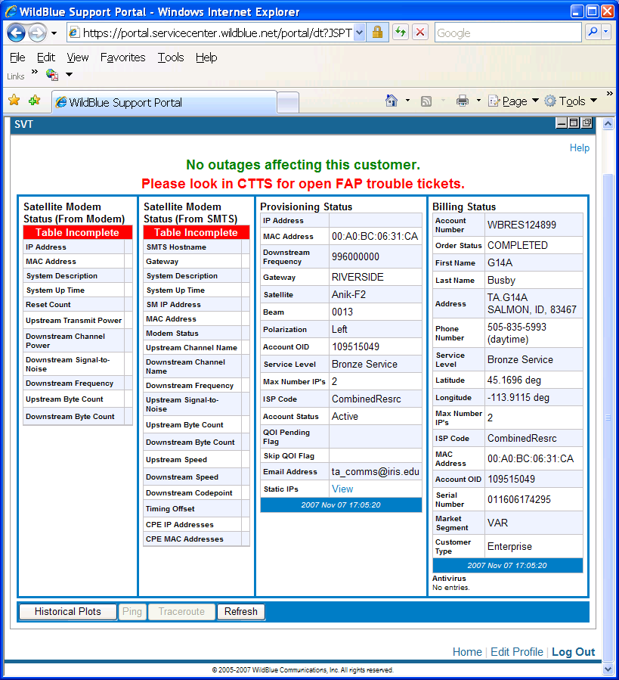

- A new window will open showing Modem history:
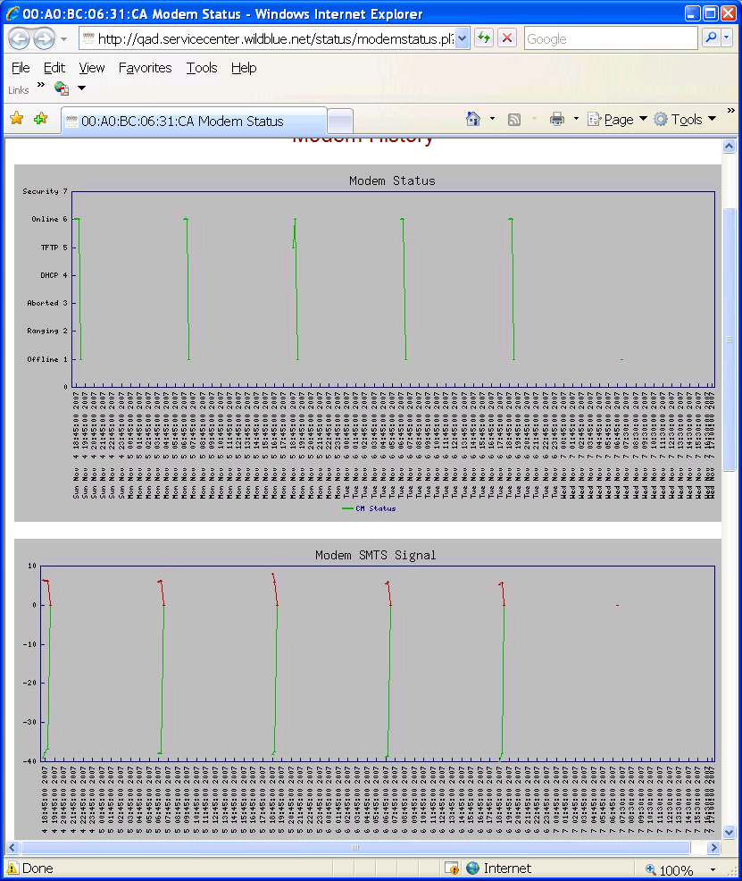

This plot shows brief periods of connectivity happening twice daily from Sunday until Tuesday evening. We check Howard’s last email about the station to see that he put in a backup power supply in case the owners shut off AC power. It will run for 1 hour 2 times a day, which is what we see until yesterday. Then no more connection. We surmise that indeed, the owners did shut off power on Saturday (registration was continuous until then) and then the backup supply ran for a few days. The landowners need to be contacted to reestablish this station’s VSAT power. If that is not possible, this station needs a full Solar VSAT installation.

- If the SVT and history for the WB station looks good, the problem might be the linksys router. Save the IP of the station [found in the Willard config file (step 29) . Another way to get the IP address for the WB stations is to click on “View” under the 3rd column of the SVT page – Provisioning Status] and open a browser window. Enter the IP followed by “:8331” and enter.
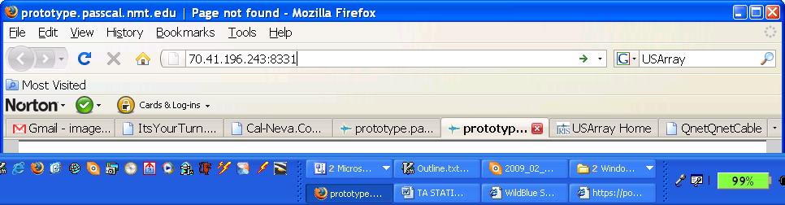

If, for some reason, the linksys router in the WB box is unable to connect – you will get a “Network timeout” or “connection interrupted” message on the browser. If it can connect, you will see the following login box:
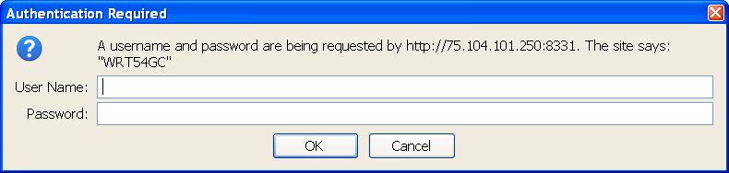

- Login to the above box with a blank user name and the password: “taops”. After a minute, the linksys seup page will open:
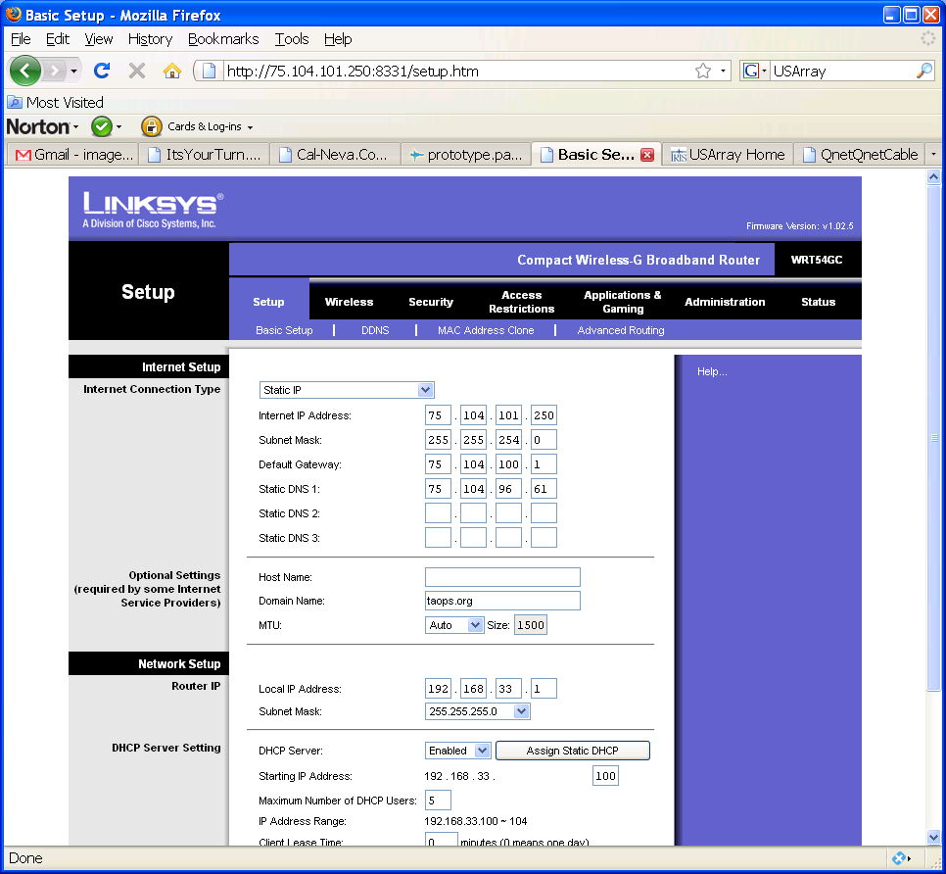

43) So if the linksys page opens, there may be something wrong with the vault, or less frequently now than last year, Wild Blue has mismanaged our IP.

44) We enter this information/surmise into the Station Problem report and do the rest of the station that need WB SVT checks from the list in step 17) and going through steps 41) for all, writing up a summary of the results onto the text file:

C14A - down 4d - WB - power cycling well until Saturday afternoon - then no more registration - may be Timer, SM, TRIA, or pointing issue
G14A - down 2d - WB - WB registration went from steady to 1 hour on, 11 hours off duty-cycle as per Howard's backup supply for when AC power was cut off. The 1 hour on periods stopped on Tuesday. Landowner called - will check AC power Friday Nov 9th
M07A - down 2d - WB - registration has had problems the last month, worsening Oct 30th. Lately it has developed a diurnal 1/2-duty cycle pattern probably caused by a VSAT power timer error. May have TRIA, SM, and/or timer problems
M13A - down 23d - WB - faulty TRIA or SM or power issue
O09A - down 27d - WB - Linksys not programmed to connect remotely - WB SVT page ok - no power cycling of the VSAT - maybe a hung Freewave master - add electro-mechanical timer
R16A - down 4d - WB - after working well, WB registration suddenly ended last Saturday - maybe VSAT power or SM or pointing issue
U13A - down 11d - WB - bad SM or TRIA or power issue
V12A - down 19d - VZ - cell comms unreachable

Checking RRD Plots for Stations with Comm Dropouts in the Previous Month

- Next, we’ll examine the ANF State of Health plots for the stations listed at the bottom of the box in step 7): A04A, A13A, C11A, D10A, E15A, F12A, G05A, G12A, K01A, N10A, and U04A. Go to http://anf.ucsd.edu/tools/soh/plots.php and click on the Red dot that is at 124A – in southern NM and you will see the following bubble appear:
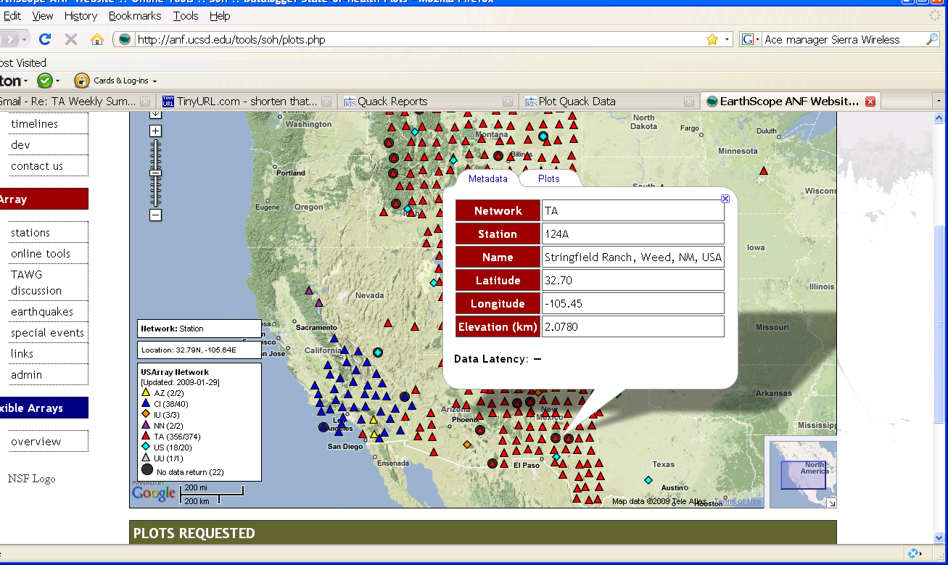

- Click on the “Plots” tab, choose All, Week:
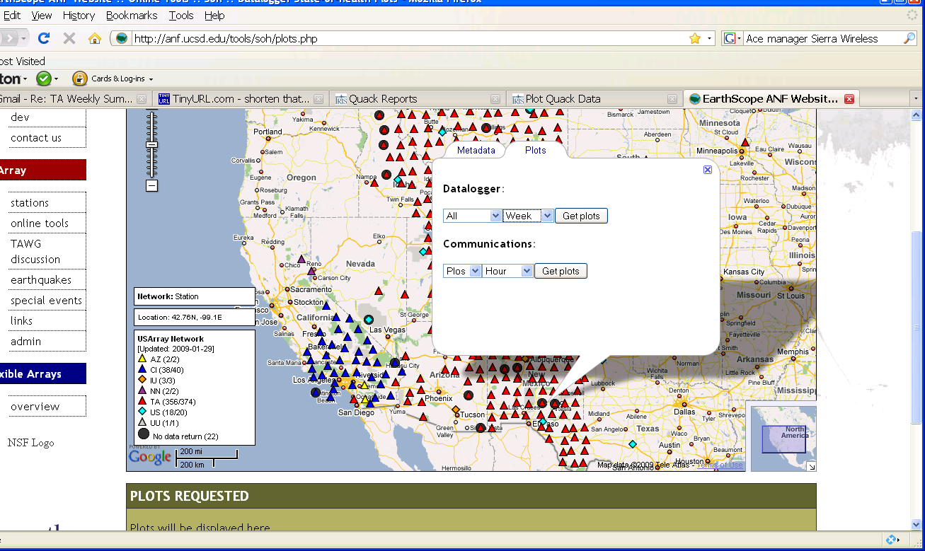

- Then click “Get Plots” The two plots we’re interested in are: Vault and IO. Comparing the 2 for station 124A shows that the radio comms went unstable late Sunday and apart from a good connection on Wednesday, comms are out. Vault power shows that daily charge cycling is proceeding fine:
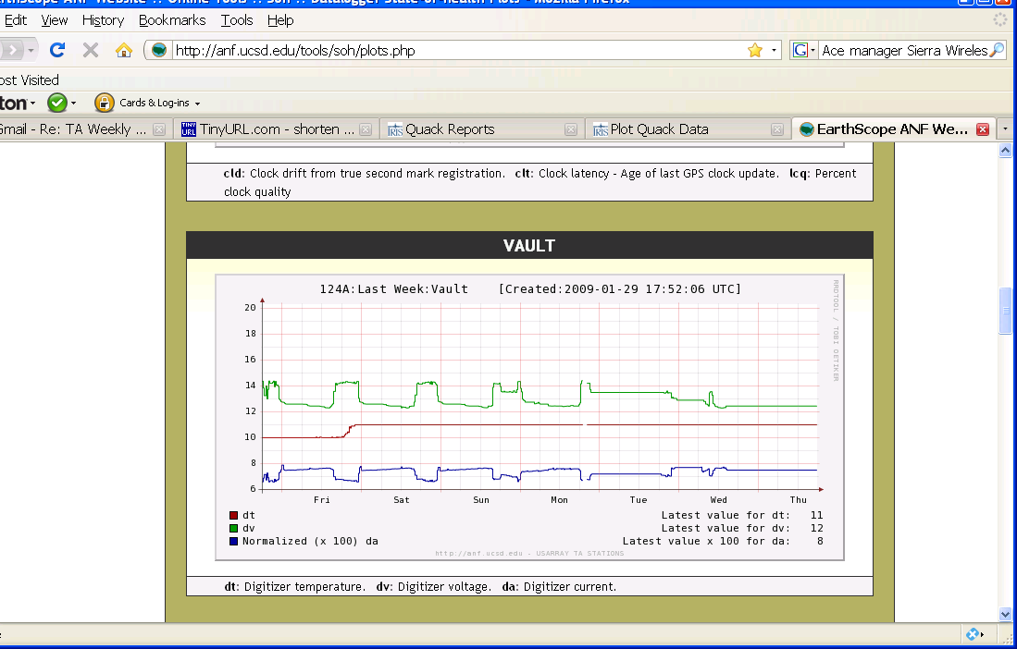

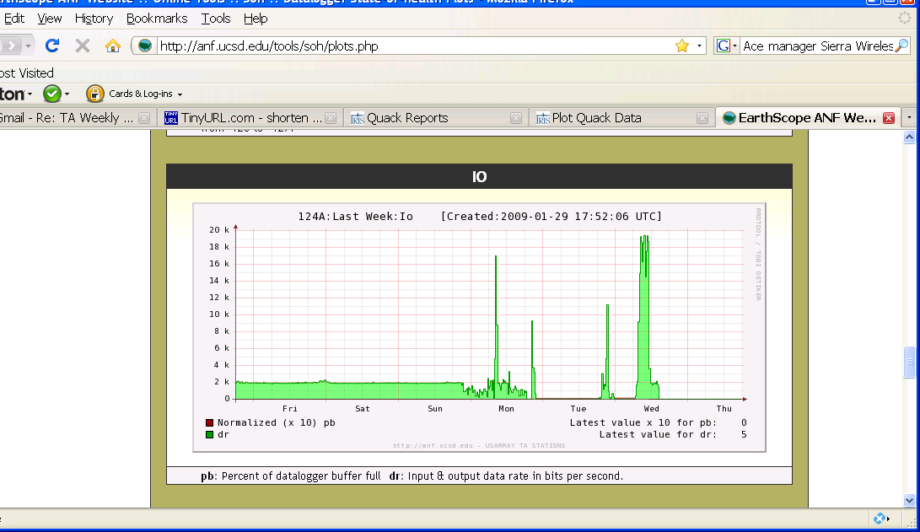

- To look at the radio signal strength timeseries, go back up to the map and select in the bubble under communications: RSSI, week and click “Get Plots” to see:
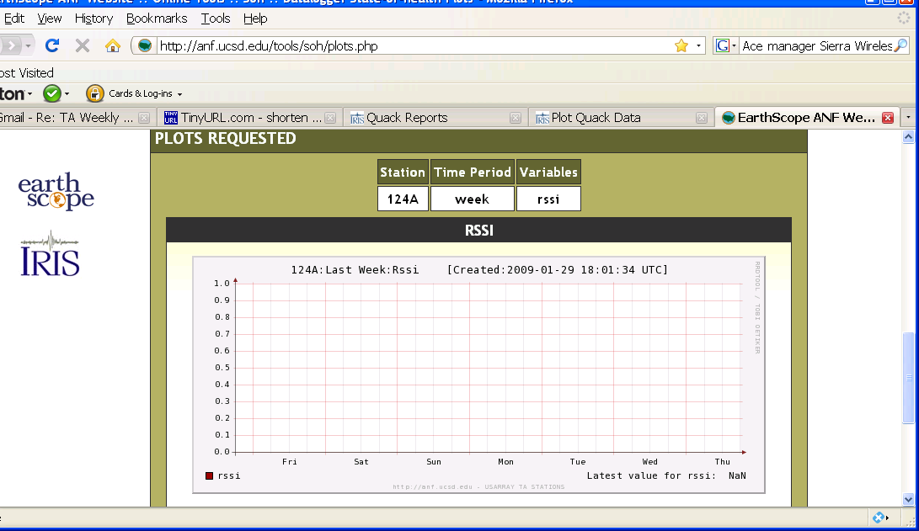

49) This indicates that RSSI reporting hasn’t been setup. It can be using Ace Manager, but only if the station is reachable.

- As we go through other stations that have comm. Problems, we tabulate the results in the following text file:
124A – power fine, comms went b
A04A - past week comms look fine
A13A - fixed a week ago by Doan (New TRIA) - looks fine since
C11A - fixed a week ago by Doan (New Inverter) - looks fine since
C16A - more than weekly dropouts - suggest checking pole and TRIA when in area
D10A - was bad at the beginning of the month, but has been fine the past 2 weekssince Doan replaced Shot Glass antenna
E15A - Down for several days the week before, then Doan replaced Shot Glass antenna - it has been fine since
F12A - A few dropouts mid - last month, has been fine the past couple of weeks - no service visit
G05A - Good service the past week - one day-long dropout the week before - no service visit
G12A - Station continues to limp along with poor Solar conditions
K01A - Similar to F12A - probably a WB glitch
N10A - good data I/O last month
U04A - nearly weekly day-long dropouts – have usually been able to connect to Linksys at these times – probably related to Freewave Master needing resetting.

- So from this list, we will add C16A and U04A to the Weekly report problem list
- Next, we check the ANF-DLMON page for low and high power volt conditions. B09A is at 11.4V as shown below:
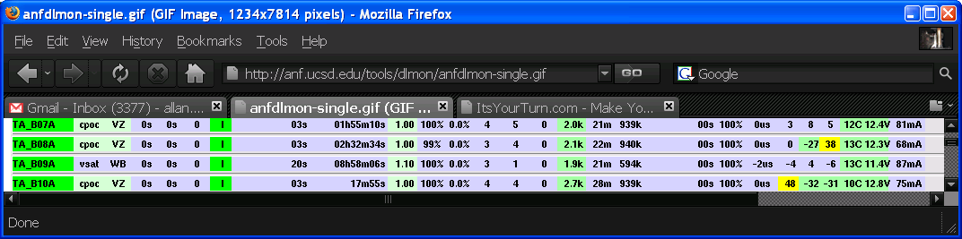
Also, U15A, L14A, Q19A, and D03A have 11.4V or lower, but we do not report these 4 stations because their power is regulated to the lower voltage before it goes to the Q330. S19A is the only station with voltage above 14.6V and we report it along with B09A in the weekly report.

53) We also look at the Low/High Voltage alarm messages that anf emails out to selected individuals. The subject is – ALARM: voltage TA_xxxx. The alarms that occurred in the past week are listed under the Low Power and High Power sections.

54) Reboot alarms are also listed under the Reboot section. If a service visit, or station came back online after a period, then these reboots are explained and not listed.

- Next, we will look up the pump status from the anf email alarm messages who’s subject is:
ALARM: pump_on TA_xxxx. Stations reported last week are taken off the list if a service visit has been paid. New stations are added to the list if they were not previously on the list and a pump alarm happened this week. Recently we have experienced a lot of false alarms and are changing out those pump sensors. No new pumps were added this week, but 2 were taken off the list – R18A got a new pump sensor, and X13A appears to have a pump connected.

- All service reports of the last week are summarized in the TA Weekly summary. These come in as anf messages from the servicer. This week’s list is as follows:

A13A – restored WB comms by replacing TRIA
E15A – restored Cell comms by replacing Shot-Glass antenna
T16A – connected pump to Aux Q330 plug
R19A – updated Q330 to 32M
R18A – replaced pump sensor
E03A – restored WB comms by replacing WB Sat Modem

57) The last thing I do for the Weekly report is cut and paste the weekly IRIS/DMC sensor report from Peggy Johnson into the TA Weekly report

